|  |
| --- |
| **Apocalypse Farmer: Core Mechanics** |
| The Methods Behind the Madness |
|  |
| This document will outline the basic core mechanics featured within the Adobe Flash based game Apocalypse Farmer. |
|  |
|  |
| **10/16/2008** |
|  |

Contents

Objectives 3

Game Structure 3

Game-Play 3

Movement Phase 3

Battling 4

Management Phase 5

Starting Conditions 5

Appendix A 6

Appendix B 7

Interview Set 1 - Thomas Tharp 7

Interview Set 2 – William McCracken 8

Interview Set 3 – Neale Petrillo 9

Appendix C – Original Core Mechanics Document 10

# Objectives

The objective of Apocalypse Farmer (from here on referred to as *the game*) is to destroy the enemy’s home village. This goal can be accomplished countless ways which provides for hours of enjoyable and never repetitive game-play.

# Game Structure

The game is made up of a playable arena comprised of a number of hex shaped sections. These hexes can be thought of as counties. Each hex contains the properties of defense bonus and productivity bonus (both based on terrain type – see Table 1). In addition, each hex has the ability to support a single community which can produce resource units (RUs) and people. For a certain cost (see Table 2) a community can be upgraded to one of greater standing.

Each community, as said, has the ability to produce RUs (which the community has control of) and people at varying rates (see Table 2); the maximum number of people a community can hold is given by the carrying capacity. It is impossible for the town to exceed that population but there is no cap on the amount of resource units the community can produce. In addition, a community can choose to form an army for a certain cost, reinforce an army located within its territory, or focus on resource production each cycle (see Table 3 ). Choosing to create an army makes a new army object located within the community’s hex. The army can then be moved to adjacent hexes.

Armies have the ability to move between hexes and found cities. The exact movement criteria will be explained later. Once an army is on an unoccupied hex it can then found a community; the community size depends on the strength (see Table 3 ). This concludes the basic structure of the game. Game-play and other specifics will be discussed in the Game-Play section of this document.

# Game-Play

Game-play is based on single turns divided into two phases: movement and management.

## Movement Phase

Movement mode is the first mode per turn. During this time a user may move a single army to an adjacent hex or choose to pass and move on to the management phase. Armies are not able to move more than one hex per turn and must, therefore, always move into an area adjacent to their current location. Should an army be directed to move into a territory occupied by an opposing player a battle scenario will commence. On the completion of a battle scenario the user will enter the management phase.

### Battling

The strength of an army is determined by its size (i.e. number of soldiers) plus its resources multiplied by a random number. The equation for determining an army’s strength can be written as:

$$S=n+(r*i)$$

Equation 1

where n is the number of people in the army, r is the number of resource units, and i is a random number determined at the time of the battle. Random numbers shall be between 0 and 1.

The defensive value of a hex is determined by the community’s defense value plus the hex’s defense modifier plus that value multiplied by a random number plus the strength of any armies currently located on the hex. The equation for determining a hex’s strength can be written as:

$$D=\left(communites defense +hex bounus\right)+ \left(\left(communities defense+hex bounus\right)* i \right)+ \sum{S_{all armies within hex limits}}$$

Equation 2

where i is a random number determined at the time of the battle and S is determined as in Equation 1 (the same i is used throughout Equation 2). Random numbers shall be between 0 and 1.

The winner is determined by greatest value. That is, if the attacking army has a greater strength then that army wins whereas if the defending hex has a greater strength it wins.

Should the attacking army be victorious it shall have its people and resources reduced by one half the defending army’s strength and any armies or communities on the hex are destroyed. If the defending hex is victorious the first army is charged half the attacking army’s strength as before. Should a remainder still exist (the first army on a hex is not strong enough to take on the attacking army) the first army is destroyed and the remainder is charged to the next army and so on. Should all armies on the hex be destroyed the hex’s community will be charged (1/3 * the remainder) to be subtracted from the community’s population.

In the event of a tie (both the attacking army and the defending hex have the same strength and defense values respectively) the victor shall be the defending hex. Should no community exist (two armies fighting each other)the defending army shall be reduced to the base case of 10 people and 10 RUs and the attacking army is destroyed. If a community exists (with or without an army present on the hex) the method of calculating loss is as before.

At the close of the battle scenario the management phase will begin.

## Management Phase

During the management phase the player will have the opportunity to assign a goal for any number of un-tasked communities (those not in a cycle), found communities, or to pass. In the event that there are no un-tasked communities, armies capable of founding communities, or the player chooses to pass the next turn will begin.

If a community is not assigned a task the default shall be to produce. At the end of the production cycle the number of RUs and people determined by the community’s resource and people production rates (see Table 2) is added to the community’s resource count and population respectively.

If a community is assigned to upgrade it is charged the appropriate amount as determined in Table 2 and is locked for the cycle as determined in Table 1. At the end of its cycle the defense value, production rates, and carrying capacity is modified.

If a community is assigned to upgrade an army in its territory it shall be charged the appropriate amount of people and RUs as determined by Table 3 and is locked for the remainder of its cycle.

If a community is assigned to create an army it is docked the appropriate amount of people and RUs as determined by Table 3 and is locked for the remainder of its cycle. At the end of its cycle a new army is created on the hex. Should the hex be attacked during the cycle and the defending community is destroyed the future army will also be destroyed.

To establish a community the player must have an army on an unoccupied hex. The army will then be charged an appropriate fee as determined by Table 3 and be unmovable until after its cycle is complete. Should the army be attacked and the defeated the new community will be lost. Should the army be attacked and win the cycle will continue unabated.

Once the player is satisfied with the setup they will push the continue button and the next turn will begin.

# Starting Conditions

Each player (computer or otherwise) begins the game with a single community placed randomly on the board as well as an army consisting of 30 people and 30 RUs.

# Appendix A

|  |  |  |
| --- | --- | --- |
| Terrain Type | Productivity Bonus | Defense Bonus |
| Plains | +5 | +0 |
| Swamps | -5 | +5 |
| Forests | +5 | +10 |

Table – Terrains

|  |  |  |  |  |  |
| --- | --- | --- | --- | --- | --- |
| Community Type | Upgrade Cost  (RUs) | Carrying Capacity (people) | Resource Production Rate (RUs / cycle) | People Production Rate  (people / cycle) | Defense Value |
| Village | - | 20 | 10 | 5 | Population + 10 |
| Town | 20 | 50 | 20 | 10 | Population + 20 |
| City | 40 | 80 | 30 | 15 | Population + 30 |

Table – Communities

|  |  |  |  |
| --- | --- | --- | --- |
| Action | Cycle Time  (turns) | Resource Cost  (RUs) | People Cost  (people) |
| Form Army | 2 | 10 + n | 10 + n |
| Reinforce Army | 1 | n | n |
| Upgrade Community | 3 | See Table 2 | 0 |
| Produce | 1 | - | - |
|  |  |  |  |
| Army Specific Actions |  |  |  |
| Found Village | 1 | 10 | 10 |
| Found Town | 2 | 20 | 20 |
| Found City | 3 | 40 | 40 |

Table – Actions and costs

# Appendix B

## Interview Set 1 - Thomas Tharp

Interview 1 – Andy

Commented on similarity to civ series

Asked how many players the game was for

Asked if an army was a bunch of game pieces together

Asked how big the board was

Asked if a combat turn starts immediately, and if it ends your turn

Interview 2 – Natalie

Asked if the villages were game pieces/if there was more than one kind of game piece

Asked how you created more villagers

Asked how you control a hex

Commented that there should be more mobile armies

Asked if you got to gather supplies from squares enemies were on

Interview 3 – Nikki

Asked about the size of the game (# players and board size)

Commented that there should be buildable improvements to villages/hexes

Commented that villagers should be able to “reproduce”

Asked what happens when you capture a village (does it's population stay the same, can you “loot” it?)

Commented that the endgame might be weak since no reinforcements or tech advances

## Interview Set 2 – William McCracken

Once common comment was that the game was simply too complicated and boring. However, with the computer keeping track of all the elements, this may not be as much of a problem.

The second comment was that it was rather boring looking. This is understandable since there is no art work at this point. However, battles could be made livelier with the addition of cartoons or music that could represent battles going on. If I stuck with the stick figure theme, battle animations could be worth putting up with the rest of the game.

Some comments were:

1. At this point, it seems more work than game - mom
2. Seems like “risk” without the interesting map - Christine
3. Where’s the “farm” component in the game? - Christine
4. One hex movement or attack rule slows down the game pace, especially for multiple unit attacks. It becomes more of a board game than a simulation. - Jeff
5. One comment suggesting that one village become a capital city and if that gets lost, then that player’s game is over. Another possibility would be that there is a main character piece which can be moved anywhere but needs to be defended at all cost. – Jeff.
6. Using unit types, rather than having varied strength and damage would simplify battle resolution. This could be justified by having each piece be worth “production units”. If a stronger piece is desired, it returns to base, is broken down into “production units” and then is reformed into a stronger piece type which costs more but has greater capability. (or could stay disbanded if “production units” are needed elsewhere).
7. Basically, all agreed that this game needs a bit of work.

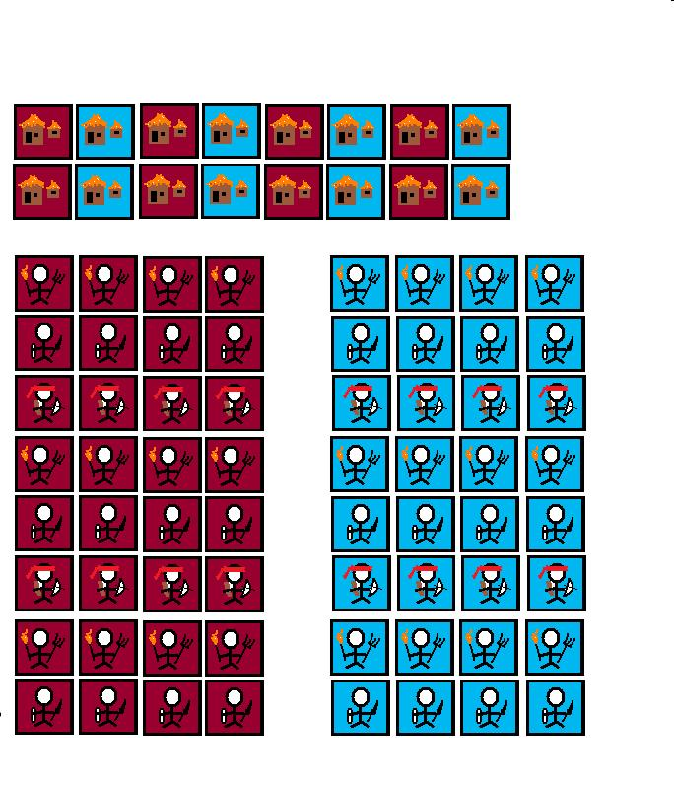

To test, a hex board was shown and cut out pieces were arranged on the board to show the general idea of the game. These were the town icons and three levels of “army dudes” from pitchfork wielding farmer, swordsman and finally the highest level piece, a ninja archer.

## Interview Set 3 – Neale Petrillo

# Appendix C – Original Core Mechanics Document

Apocalypse Farmer

Object of the Game:

To capture all enemy village and leave all enemies with a total army strength of less than 4.

Initial conditions:

All players start with 1 village which has a total population of 50 along with 10 supply units.

On your turn:

When it's the player's turn, the player can choose to do one of four things: move an army, create an army, outfit an army, or found a village.

If the player chooses to move an army, the player will select one piece, and move it to a valid adjacent hex (one which is not impassible). If the selected destination hex is controlled by an enemy, a combat turn will begin.

The player may choose to create an army in a village if the player has a suitable village with population greater than 4, and at least 10 supply units in said village. The player will then take a portion of the population of the village (leaving at least 4 in the village), and spend 10 supply units per villager taken to outfit them as an army. This will create a game piece on the village hex with strength equal to the number of villagers taken from the village.

The player may outfit an army if they have an army piece on a village hex. They can increase the attack modifier of a piece at the cost of 20 supply units times the amount the modifier is being increased.

The player may found a village if the player has a suitable army (one with a strength of at least 4) on a suitable hex (one which is not adjacent to a hex controlled by the enemy). The strength of the army will be decreased by at least 4 or ½ of the army's size (rounded up), whichever is greater. The population of the village will be equal to the strength deducted from the founding army. The amount of supplies in the village will be equal to the attack modifier of the founding army divided by 2 (rounded up).

At the beginning of every player's turn, each of their village's supplies increase by a value equal to the sum of the productivity bonuses of the village hex and all adjacent hexes.

If at the end of a player's turn, any player both has no villages and has a total army strength of less than 4, that player shall be eliminated from the game, and all their game pieces removed from play.

On a combat turn:

If the attacked hex has more than one game piece on it, the attacking player will choose the order in which the attacking piece will roll against the defending pieces. If the attacker's strength plus the attack modifiers of the piece and the hex is greater than the sum of the defenders' strengths plus the hex defense modifier all multiplied by 1.5, then the attack is successful. The defending units are removed from the game, the attacking unit's strength is decreased by sum of the defenders' strengths. Otherwise, the attack is unsuccessful. In that case, the attacking piece is removed from the game, and the defenders' strengths are in total reduced by the value of the attacker's strength. (Strength is reduced in the order that the attacking player chose before the attack. Some defending pieces may end up being reduced to 0, in which case they are removed from play).

If the attacked hex is a village hex, then half of the village's population is added to the defenders' strength when determining attack success. If the attack succeeds, then the village belongs to the attacking player, and all supplies in it are destroyed. Otherwise, combat behaves normally on a village hex.

Types of Hexes:

Plains: +1 productivity bonus, +1 attack bonus, and +0 defense bonus

Swamps: -1 productivity bonus, +1 attack bonus, +1 defense bonus

Hills: +0 productivity bonus, +1 attack bonus, +2 defense bonus

Forests: +1 productivity bonus, +2 attack bonus, +2 defense bonus

Villages: +3 productivity bonus, +0 attack bonus, +3 defense bonus

Impassible: -3 productivity bonus